Abstract

The purpose of this project is to build a model using ArcGIS. The model will be used to determine appropriate sites for installing commercial-scale solar photovoltaic (PV) of 1,000 kW (AC) or larger throughout Anchorage, Alaska, with lower cost and higher efficiency. This work is based on previous East Bay Community Energy (EBCE) project by Clean Coalition. Light Detection and Ranging (LiDAR) data from 2015 covering Anchorage was provided and analyzed. Final siting map is generated and shown in .kml file.

Introduction

Increasing interest in utilizing solar power has rised in Alaska due to the increasing cost of other energy resources and some environmental concerns. Anchorage used to be a relatively small market of solar energy. However, it has been developing rapidly since 2011 as solar technology has improved to better take advantage of long summer in Alaska and make it work in winter. Therefore, the need to determine where to set up new solar panels more quickly brought about this project to build a model using ArcGIS, which, provided LiDAR data, could accurately find high-quality sites for solar panels.

LiDAR is a remote sensing method that uses pulsed laser to measure variable distances from the earth. Combining the data from Airborne System, it could give precise three-dimensional information about the shape of Earth and its surface characteristics.

The approach starts with raw LiDAR, dividing the points into different classes: buiding, vegetatioin, bare ground etc., and creating shape files of feature classes. Then the buidings will be picked for further analysis to choose usable rooftops according to information such as minimum and maximum elevations (showing pitche or flat roof), aspect, their area, etc. The parking lots are processed similarly. However, because of their diverse and complex structures, it is hard to generate classification function to automatically assign a structure to parking lot class. The parking lots were manually picked using parking signs on the map. Furthermore, fire tracks also needed more attention when dealing with parking lots.

Data and Methodology

The LiDAR survey, covering area arounf 957 square miles in and around Anchrage Alaska, was performed by Merrick and Company (Merrick), who was contracted with Municipality of Anchorage (MOA). The current coordinate system is NAD_1983_StatePlane_Alaska_4_FIPS_5004(US feet). Approximately 240 .las files from the entire dataset were employed based on Anchorage community councils. The targeted density of the LiDAR point cloud was planned at a minimum of two points per square meter (2ppsm) and four points per square meter (4ppsm), while the Vertical Accuracy = 9.25cm in the interest of meeting a 1 foot contour accuracy specification.

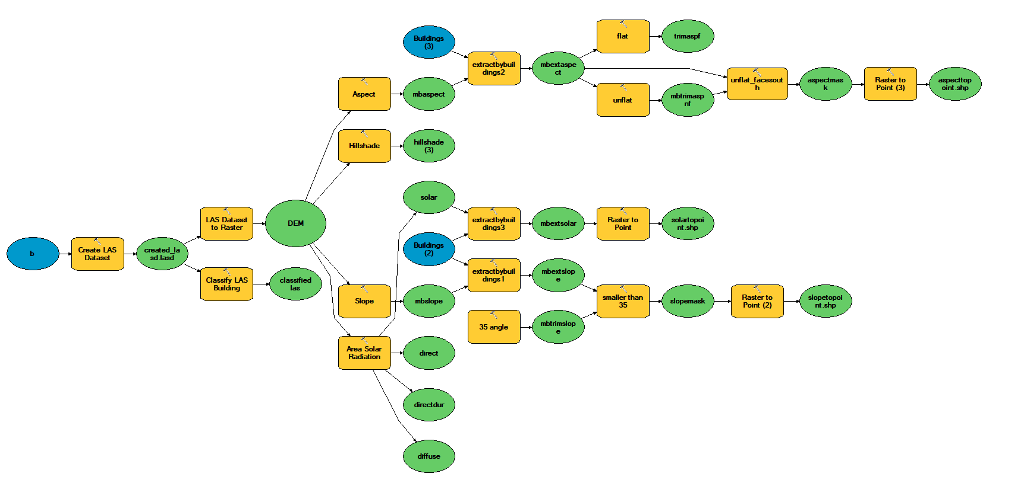

Figure 1. Model builder to generate shapefiles

The figure above shows the process of the model to decide if a rooftop of s building is suitable for desired solar panel installation.

First, a LAS dataset is generated using the LAS files picked. There are several tools in ArcGIS could finish this task. The context menu of ArcMap catalogue or Arc Catalogue could create one new LAS dataset directly. Las dataset has file extension ‘.lasd’. A LAS dataset could store reference to more than one LAS files at once and quickly display lidar data as point clouds or a triangulated surface in 2D and 3D.

The LAS dataset then be used to classify buildings. A set of numeric codes were assigned to each LiDAR points with 1 as unassigned and 6 as building. Those points with code 6 were just filtered and selected. Those points with code were classified with the help of GDB file for buildings. All the other points were then dropped.

In addition, LAS dataset was also used to additional surfaces such as DEMs (LAS Dataset To Raster geoprocessing tool). LAS dataset is used as input, a digital elevation model(DEM) was then derived and saved as a floating-point raster image. The raster was georeferenced using the Georeferencing toolbar in ArcGIS.

A solar map was generated using Area Radiation Tool from georeferenced images. The Area Solar Radiation tool estimates total insolation as sum of diffuse and direct radiation. The mean latitude was automatically calculated using input spatial raster. The other specific parameter used are as following: the resolution was set to 300; The time configuration(period) was specified as from the 5th and 160th day of 2018; Day interval used for calculation was set to 15 while hour interval set to 0.5; The slope and aspect rasters are calculated from the input surface raster. The other parameters were default set by program. This solar map takes into account the position of sun, the azimuth (change of elevation) and any shading effect caused by buildings or other objects in the input raster that blocks the sunlight.

see if there are any trees, buildings, or other objects that are blocking potential sunlight.

Four masks were produced in the use of selecting desired characteristics of the locations. Aspect masks works to choose suitable aspects. Since Anchorage is in the northern hemisphere. Solar panel should be south-facing to get higher solar power. It was generated from georeferenced image and it was binary: 1 for pass and 0 for fail. More specifically, aspect with between 112.5 to 247.5 was suitable since it represents the south. Other masks were generated similarly: Slope masks chose flat rooftop with slope less than 35 degree; Radiation mask set the minimum radiation threshold based on the efficiency of the solar panels; Hillshade mask decides the minimum number of days the position was in the shade.

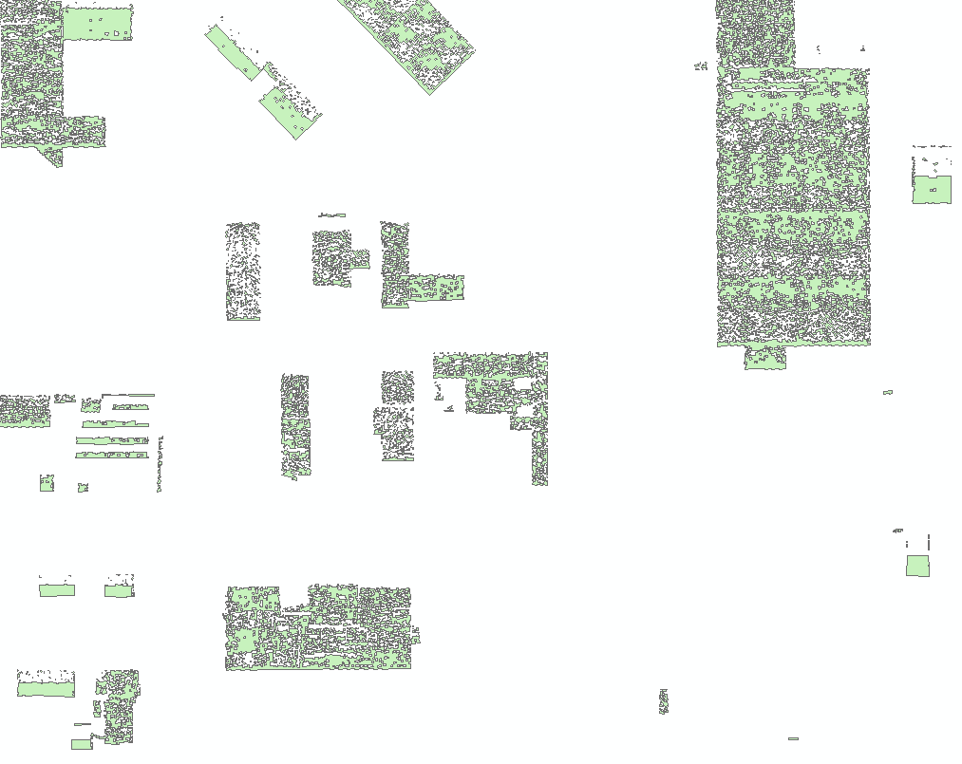

Figure2. Example of regularized total mask

The Extract by Mask tool was then utilized to extracts the cells of a raster that correspond to the areas defined by a mask. This will be used as input of Raster to Point tool that generate feature shape files for suitable places (point features). The Aggregate points tool was then employed to summarize a set of point features, before zonal statistics were calculated. The results of statistics would be used in the basis of the standard of the solar panels to do one more filtering and selecting processes. One-and-a-half square meters was used as the required area for each solar panel.

Results:

The following deliverables are built:

1. .kml (Keyhole Markup Language) files for case study area, which can be displayed on Google Earth or imported into Google Maps;
2. xslx (Excel) spreadsheet containing all the data used to generate the .kml file, as well as summary breakdowns of the findings.

Discussion and Conclusion

There are several limitations for this study. First, the unclassified buildings were selected with building GDB files provided. Thus, this approach is not going to work well if the building data is not available. Besides, there are noises not able to be eliminated completely, such as big trucks classified as buildings. The other limitation is shading effect was not fully analyzed by just using Hillshade mask. More elements are needed considering. For example, what time during the day is the location in shade. The other thing needed improving is the consideration of the budget.